**CONTENTS**

|  |  |  |  |
| --- | --- | --- | --- |
| **SN** | **Title** | **Page** | **Remark** |
| **1.** | **Abstract** | **3** |  |
| **2.** | **Introduction** | **3** |  |
| **3.** | **Literature Survey** | **4** |  |
| **4.** | **WebPages (with Source Codes)** | **5** |  |
| **5.** | **Related Concepts and Principles** | **17** |  |
| **6.** | **Hardware and Software Requirement** | **18** |  |
| **7.** | **Proposed Algorithm/ Method/ Techniques** | **19** |  |
| **8.** | **References (Books, Websites, Journals, Research Papers)** | **20** |  |

1. **Abstract**

Our proposed system is an online food ordering system that enables ease for the customers. It overcomes the disadvantages of the traditional queueing system. Our proposed system is a medium to order online food hassle free from restaurants as well as mess service. This system improves the method of taking the order from customer. The online food ordering system sets up a food menu online and customers can easily place the order as per their wish. Also with a food menu, customers can easily track the orders. This system also provides a feedback system in which user can rate the food items.

1. **Introduction**

**The project titled as “Foodify” is a revolutionary website that allows college students to order food items from campus canteen with ease. Our website makes it easy for you to browse menus. Our platform is designed to make the ordering process simple and hassle-free, allowing students to focus on their studies while still enjoying delicious meals from the canteen. We understand the busy schedules of college students and strive to provide a convenient and efficient service. Our team is dedicated to providing the best customer service and ensuring that all orders are delivered on time and to the highest quality. With Foodify, you can say goodbye to long lines and crowded canteens and hello to a seamless and satisfying food ordering experience.**

The website consists of total 9 webpages, out of 5 are currently under development phase.

The main pages are:

* **Login Page: User can sign-in to foodify using his/her credentials.**
* **Home Page: With the help of this webpage user can select food item form the few featured food items.**
* **About Page: This webpage tells about the website and the our hardworking team.**
* **Contact Page: User can contact the support team with mentioned details of our team.**

1. **Literature Survey**

In [1] an automated food ordering system is proposed which will keep track of user orders smartly. Basically, they implemented a food ordering system for different type of restaurants in which user will make order or make custom food by one click only. By means of web application for Tablet PCs this system was implemented. The front end was developed using HTML & CSS.

In [2] Customer using a Smartphone is considered as a basic assumption for the system. When the customer approach to the restaurant, the saved order can be confirmed by touching the Smartphone. The list of selected preordered items shall be shown on the kitchen screen, and when confirmed, order slip shall be printed for further order processing. The solution provides easy and convenient way to select pre-order transaction form customers.

In [3] there was an attempt to design and implementation of digital dining in restaurants using android technology. This system was a basic dynamic database utility system which fetches all information from a centralized database. Efficiency and accuracy of restaurants as well as human errors were improved by this user-friendly application. Earlier drawbacks of automated food ordering systems were overcome by this system and it requires a onetime investment for gadgets.

In [4] along with customer feedback for a restaurant a design and execution of wireless food ordering system was carried out. It enables restaurant owners to setup the system in wireless environment and update menu presentations easily. Smart phone has been integrated in the customizable wireless food ordering system with real-time customer feedback implementation to facilitate real-time communication between restaurant owners and customers.

**4.Webpages & Source Code**

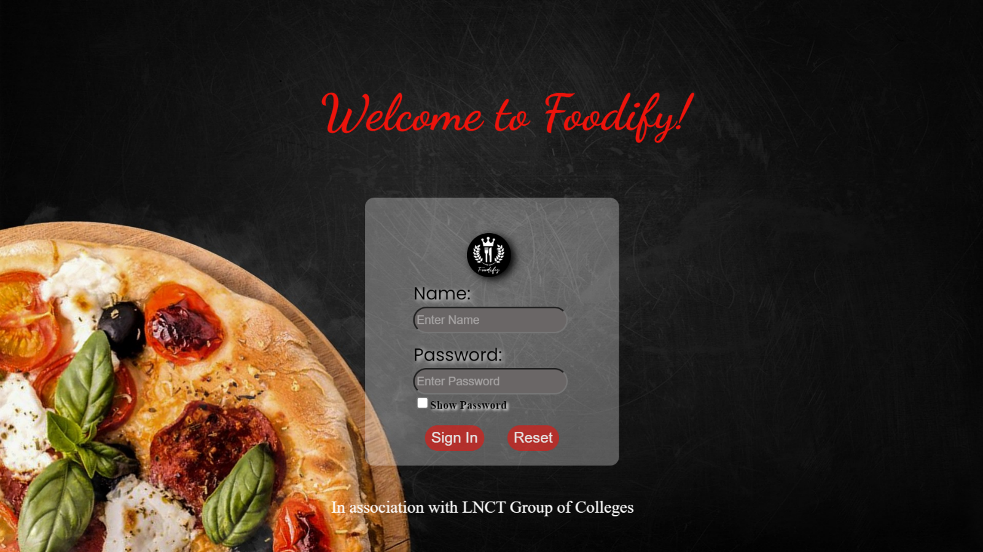**Login Page:**

**Home Page:**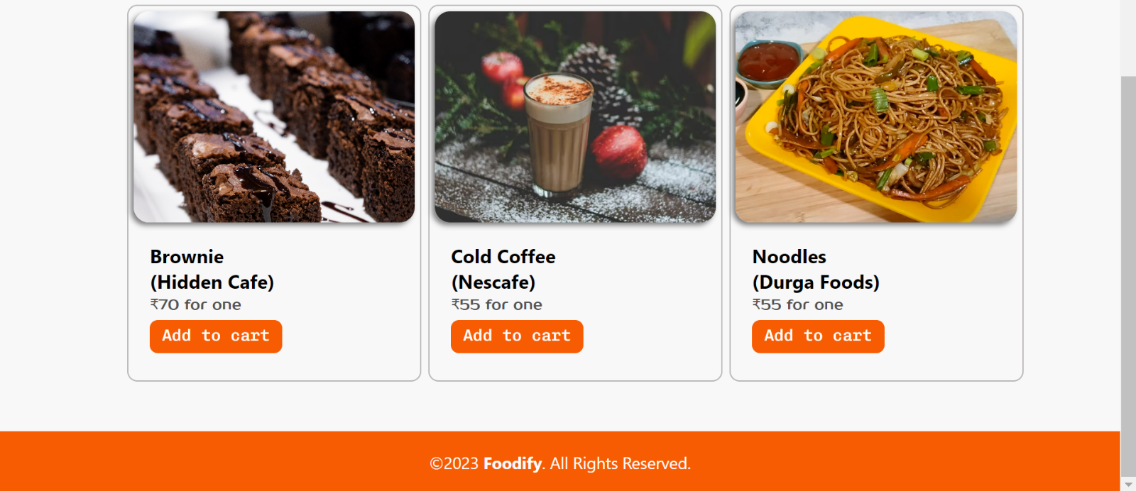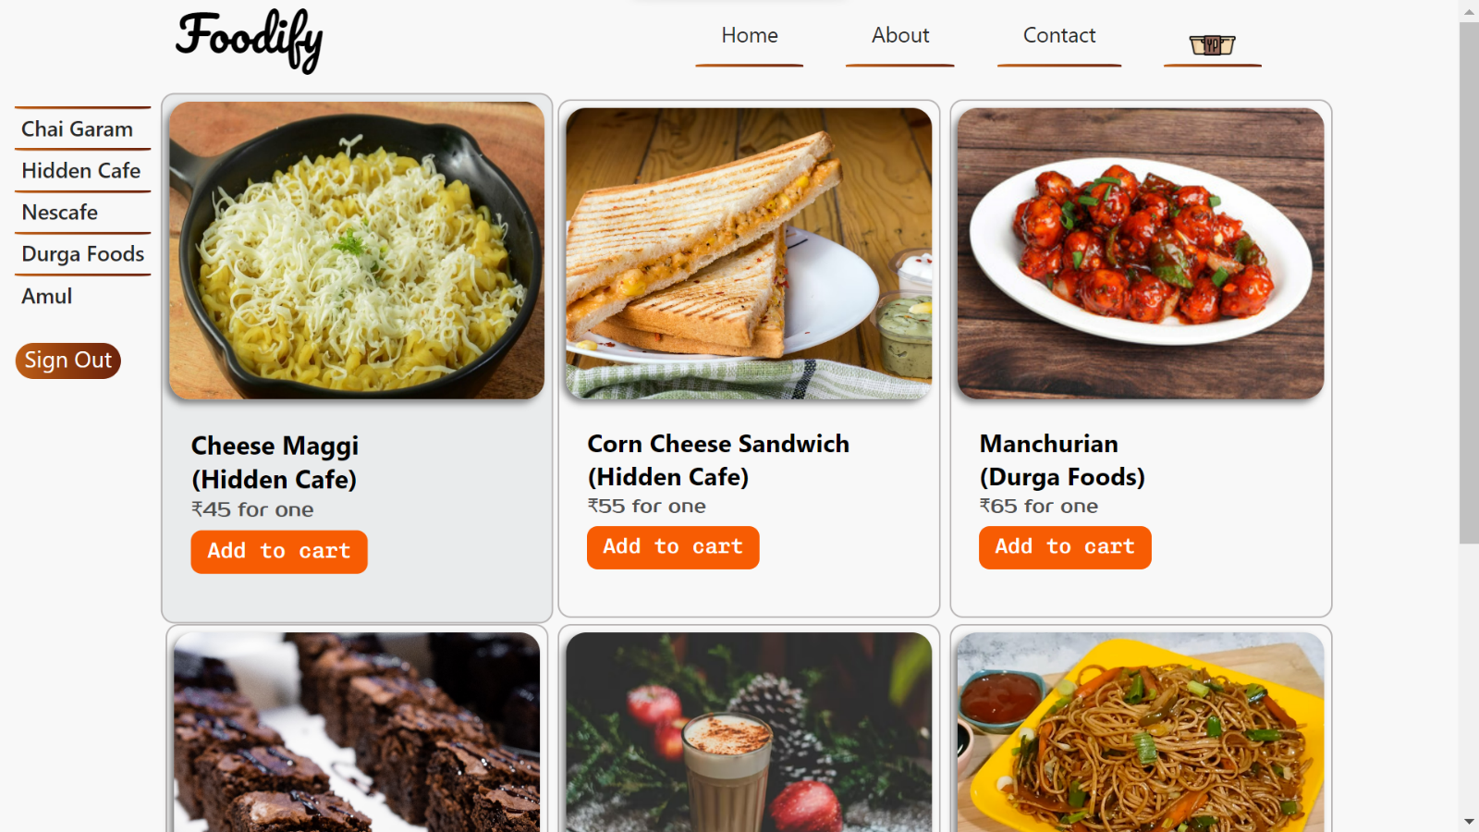

**Source Code:**

**HTML:**

<!DOCTYPE html>

<html lang="en">

<head>

    <meta charset="UTF-8">

    <meta http-equiv="X-UA-Compatible" content="IE=edge">

    <meta name="viewport" content="width=device-width, initial-scale=1.0">

    <title>Foodify</title>

    <!-- CSS stylesheet -->

    <link rel="stylesheet" href="style_home.css">

    <!-- FONT LINKS -->

    <link rel="preconnect" href="https://fonts.googleapis.com">

    <link rel="preconnect" href="https://fonts.gstatic.com" crossorigin>

    <link href="https://fonts.googleapis.com/css2?family=Prosto+One&display=swap" rel="stylesheet">

    <link href="https://fonts.googleapis.com/css2?family=Chivo+Mono:ital,wght@0,100;0,200;0,300;0,400;0,500;0,600;0,700;0,800;0,900;1,100;1,200;1,300;1,400;1,500;1,600;1,700;1,800;1,900&display=swap" rel="stylesheet">

    <link href="https://fonts.googleapis.com/css2?family=Pacifico&display=swap" rel="stylesheet">

    <link href="https://cdn.jsdelivr.net/npm/remixicon@3.5.0/fonts/remixicon.css" rel="stylesheet">

</head>

<body>

    <header>

        <p><a class = "logo" href="home.html">Foodify </a></p>

        <div class="nav">

            <ol>

                <li><a href="home.html"class="underline" >Home</a></li>

                <li><a href="about.html"class="underline" >About</a></li>

                <li><a href="contact.html"class="underline" >Contact</a></li>

                <li>

                    <button class="crt-on">

                    <img id="cart" src="https://cdn-icons-png.flaticon.com/512/2203/2203288.png" alt="">

                    <span class="quantity"></span>

                    </button>

                </li>

            </ol>

        </div>

    </header>

    <div id="container">

        <div id="hero">

            <div id="sidepane">

                <a href="cg.html" id="cafe1" class="cafe">Chai Garam</a>

                <a href="hc.html" id="cafe2" class="cafe">Hidden Cafe</a>

                <a href="nescafe.html" id="cafe3" class="cafe">Nescafe </a>

                <a href="df.html" id="cafe4" class="cafe">Durga Foods</a>

                <a href="amul.html" id="cafe6" class="cafe">Amul </a>

                <a href="login.html"><button class="buttons black" type="sign in">Sign Out</button></a>

            </div>

            <div id="card">

                <div class="card" style="width: 18rem">

                    <img src="Images/cheese-maggi.jpg"

                     class="card-img-top bdr-menu" alt="maggi">

                    <div class="card-body">

                        <h3 class="card-title">Cheese Maggi <br>(Hidden Cafe)</h3>

                        <p class="card-text">₹45 for one</p>

                        <button class="bton">Add to cart</button>

                    </div>

                </div>

                <div class="card" style="width: 18rem">

                    <img src="https://images.unsplash.com/photo-1528736235302-52922df5c122?ixlib=rb-4.0.3&ixid=MnwxMjA3fDB8MHxwaG90by1wYWdlfHx8fGVufDB8fHx8&auto=format&fit=crop&w=954&q=80"

                    class="card-img-top bdr-menu" alt="...">

                    <div class="card-body">

                        <h3 class="card-title">Corn Cheese Sandwich <br>(Hidden Cafe)</h3>

                        <p class="card-text">₹55 for one</p>

                        <button class="bton">Add to cart</button>

                    </div>

                </div>

                <div class="card" style="width: 18rem">

                    <img src="https://t3.ftcdn.net/jpg/04/47/95/48/240_F_447954890_nYoJ3Lm6OElMe0LogDry2KfHF4tXsfMw.jpg"

                    class="card-img-top bdr-menu" alt="...">

                    <div class="card-body">

                        <h3 class="card-title">Manchurian <br>(Durga Foods)</h3>

                        <p class="card-text">₹65 for one</p>

                        <button class="bton">Add to cart</button>

                    </div>

                </div>

                <div class="card" style="width: 18rem">

                    <img src="Images/brownie.jpg"

                    class="card-img-top bdr-menu" alt="...">

                    <div class="card-body">

                        <h3 class="card-title">Brownie <br>(Hidden Cafe)</h3>

                        <p class="card-text">₹70 for one</p>

                        <button class="bton">Add to cart</button>

                    </div>

                </div>

                <div class="card" style="width: 18rem">

                    <img src="https://images.unsplash.com/photo-1481455473976-c280ae7c10f9?ixlib=rb-4.0.3&ixid=MnwxMjA3fDB8MHxzZWFyY2h8MjZ8fENvbGQlMjBjb2ZmZWV8ZW58MHx8MHx8&auto=format&fit=crop&w=600&q=60"

                    class="card-img-top bdr-menu" alt="...">

                    <div class="card-body">

                        <h3 class="card-title">Cold Coffee <br>(Nescafe)</h3>

                        <p class="card-text">₹55 for one</p>

                        <button class="bton">Add to cart</button>

                    </div>

                </div>

                <div class="card" style="width: 18rem">

                    <img src="Images/noodles.jpg"

                    class="card-img-top bdr-menu" alt="...">

                    <div class="card-body">

                        <h3 class="card-title">Noodles <br>(Durga Foods)</h3>

                        <p class="card-text">₹55 for one</p>

                        <button class="bton">Add to cart</button>

                    </div>

                </div>

            </div>

            <div class="cart-box">

                <h1>Cart</h1>

                <hr>

                <div class="cart-items">

                </div>

            </div>

        </div>

        <div id="footer">

           <p>©2023 <b>Foodify</b>. All Rights Reserved.</p>

        </div>

    </div>

        <!-- JavaScript -->

        <script src="cart.js"></script>

</body>

</html>

**CSS:**

* {

    margin: 0px;

    padding: 0px;

    box-sizing: border-box;

    font-family: system-ui, -apple-system, "Segoe UI", Roboto, "Helvetica Neue", "Noto Sans", "Liberation Sans", Arial, sans-serif, "Apple Color Emoji", "Segoe UI Emoji", "Segoe UI Symbol", "Noto Color Emoji";

}

body{

    background-color: #F8F8F8;

    position: relative;

    min-height: 100vh;

    padding-bottom: 10px;

}

#container {

    height: 100%;

    margin-top: 20px;

}

header{

    width: 100%;

    height: 50px;

    background: #F8F8F8;

    display: flex;

    justify-content: space-around;

    align-items: center;

}

header div ol li .quantity{

    background-color: red;

    border-radius: 50%;

    display: flex;

    justify-content: center;

    align-items: center;

    color: #fff;

    position: absolute;

    top: 10.5px;

    left: 83.5%;

    padding: 2px 9px;

    z-index: 1;

}

.logo{

    font-size: 2.2em;

    text-decoration: none;

    color: rgb(0, 0, 0);

    font-family: 'Pacifico', cursive;

}

.nav{

    display: flex;

    align-items: center;

}

.nav ol{

    display: flex;

    list-style: none;

}

.nav ol li{

    margin: 1em;

}

.nav ol li a{

    text-decoration: none;

    padding: 0.2em 1.2em 0.9em 1.2em;

    border-radius: 10px 10px 0 0;

    color: rgb(39, 39, 39);

    transition: all .4s;

    position: relative;

    z-index: 1;

}

.nav ol li .underline::before{

    content: '';

    position: absolute;

    bottom: 0;

    left: 0;

    width: 100%;

    height: 41px;

    border-radius: 10px 10px 0 0;

    background: #853333;

    transform-origin: bottom;

    background: linear-gradient(to right, #c06017, #903c0e, #6b230d);

    transform: scaleY(0.05);

    z-index: -1;

    transition: all .4s;

}

.nav ol li .underline:hover::before{transform: scaleY(1.1);}

.nav ol li .underline:hover{

    color: white;

}

.buttons {

    margin-top: 20px;

    font-size: 17px;

    border: 1px solid ;

    border-radius: 15px;

    padding-left: 7px;

    padding-right: 7px;

    padding-bottom: 5px;

}

.buttons:hover{

    transform: scale(1.1);

    transition: all 0.5s;

}

.black {

    background: linear-gradient(to right, #c06017, #903c0e, #6b230d);

    color: white;

}

#cart {

    height: 35px;

    width: 35px;

    margin-top: -5px;

    margin-bottom: -20px;

}

#hero {

    display: flex;

    width: 100%;

    margin-bottom: 100px;

}

#sidepane {

    display: flex;

    flex-direction: column;

    margin: 5px;

    width: max-content;

    height: max-content;

    padding: 5px 6px;

    border-radius: 6px;

}

.cafe {

    text-decoration: none;

    height: fit-content;

    width: auto;

    padding: 5px;

    box-sizing: border-box;

    font-weight: 500;

    border-radius: 10px 10px 0 0;

    color: rgb(39, 39, 39);

    transition: all .4s;

    position: relative;

    z-index: 1;

}

.cafe::before{

    content: '';

    position: absolute;

    top: 0;

    left: 0;

    width: 100%;

    height: 41px;

    border-radius: 0px 0px 10px 10px;

    background: #853333;

    transform-origin: top;

    background: linear-gradient(to right, #c06017, #903c0e, #6b230d);

    transform: scaleY(0.05);

    z-index: -1;

    transition: all .4s;

}

.cafe:hover::before{transform: scaleY(0.7);}

.cafe:hover{color: white;}

#card{

    display: flex;

    flex-flow: row wrap;

}

.card {

    margin-right: 7px;

    border: 1.70px solid rgb(184, 181, 181);

    border-top-left-radius: 10px;

    border-top-right-radius: 10px;

    border-bottom-left-radius: 10px;

    border-bottom-right-radius: 10px;

    margin-top: 5px;

    padding: 5px;

}

.card:hover{

    background-color: #e9ebec;

    transform: scale(1.025);

    margin-right: 7px;

}

.card-body {

    flex: 1rem 1rem auto;

    padding: 1rem 1rem;

}

.card-img-top {

    height: 58%;

    width: 100%;

    object-fit: cover ;

    float: inline-end;

    box-sizing: border-box;

    box-shadow: -3px 3px 5px grey;

}

.card-text {

    color: rgb(80, 80, 80);

    font-family: 'Prosto One', cursive;

    font-size: 14px;

    margin-bottom: 9px;

    font-weight: 460;

}

.bton {

    background-color: rgb(247, 92, 3);

    padding: 5px 12px;

    padding-bottom: 8px;

    font-size: 16px;

    font-weight: 500;

    color: white;

    border-radius: 8px;

    border: none;

    text-decoration: none;

    font-family: 'Chivo Mono', monospace;

}

.bton:hover {

    background-color: rgb(232, 41, 8);

    font-size: 18px;

    color: white;

    transition: 0.20s;

}

#footer{

    margin-top: 20px;

    padding: 20px;

    display: flex;

    justify-content: center;

    background-color: rgb(247, 92, 3);

    color: white;

    position: absolute;    bottom: 0;    left: 0;    right: 0;

}

.chai-garam{

    margin-top: 20px;

    margin-left: 20px;

    height: 450px;

    width: 250px;

    position: relative;

}

.chai-garam:hover{

    transform: scale(1.05);

}

#p-menu{

    margin-top: 19%;

    margin-left: 15%;

    font-size: 20px;

    font-weight: bold;

}

#amul-menu{

    display: flex;

    flex-flow: row wrap;

}

#p-amul-menu{

    margin-top: 15%;

    margin-left: 5%;

    font-size: 20px;

    font-weight: bold;

}

.bdr-menu{

    border-top-left-radius: 15px;

    border-top-right-radius: 15px;

    border-bottom-left-radius: 15px;

    border-bottom-right-radius: 15px;

}

.cart-box{

    width: 100px;

    background-color: #6b230d;

}

.crt-on{

    border: none;

}

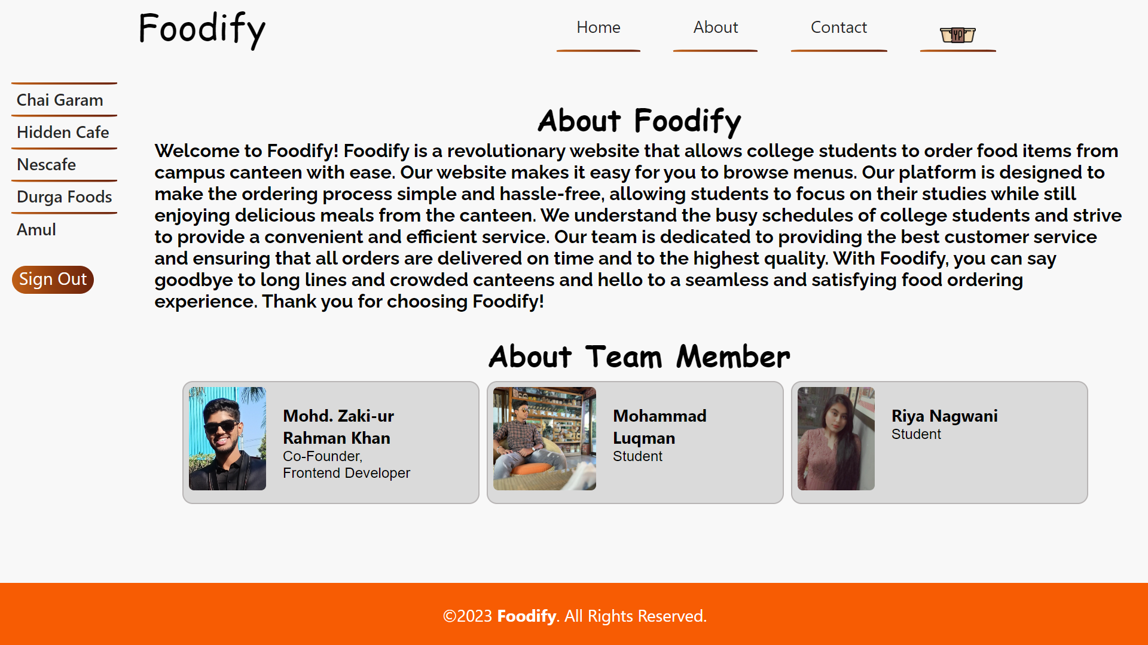**About Page:**

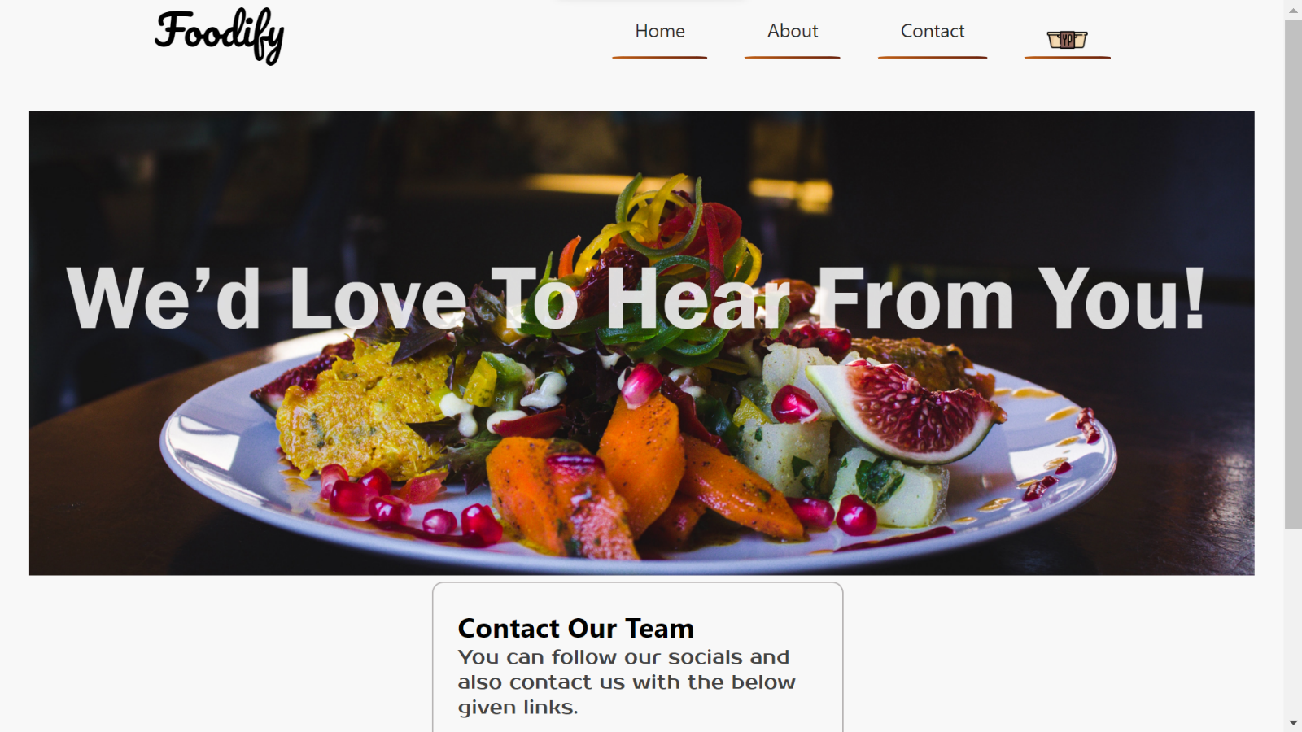**Contact Page:**

**CAFÉ Menu Page:**

1. Chai Garam:

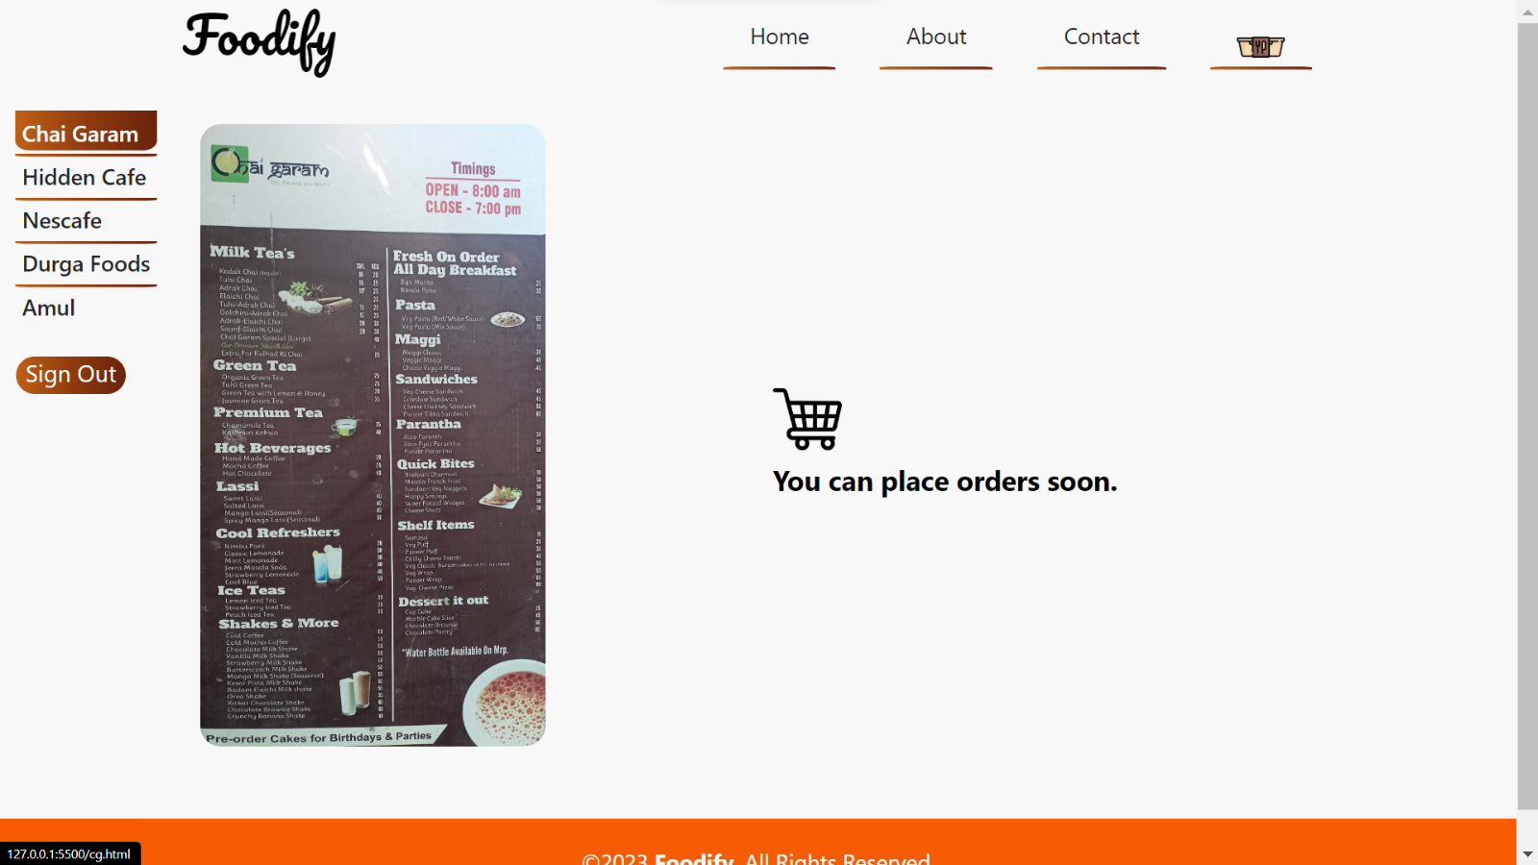**Output:**

1. 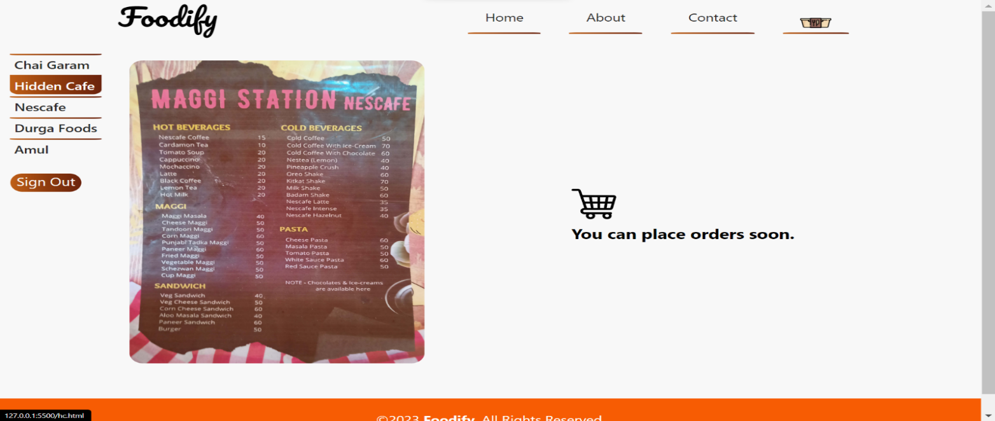Hidden Cafe:
2. Nescafe:

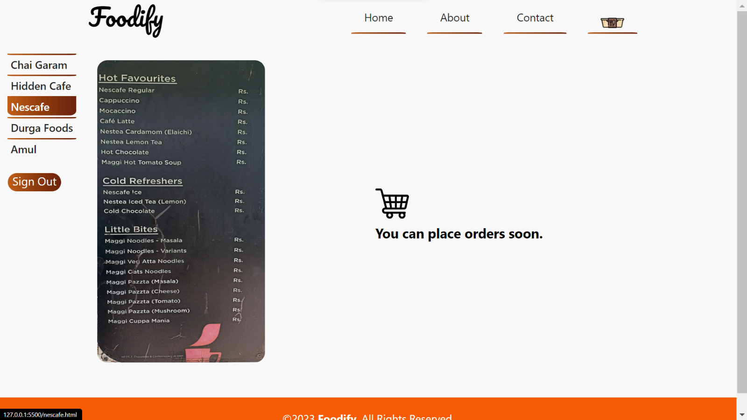

1. Durga Foods:

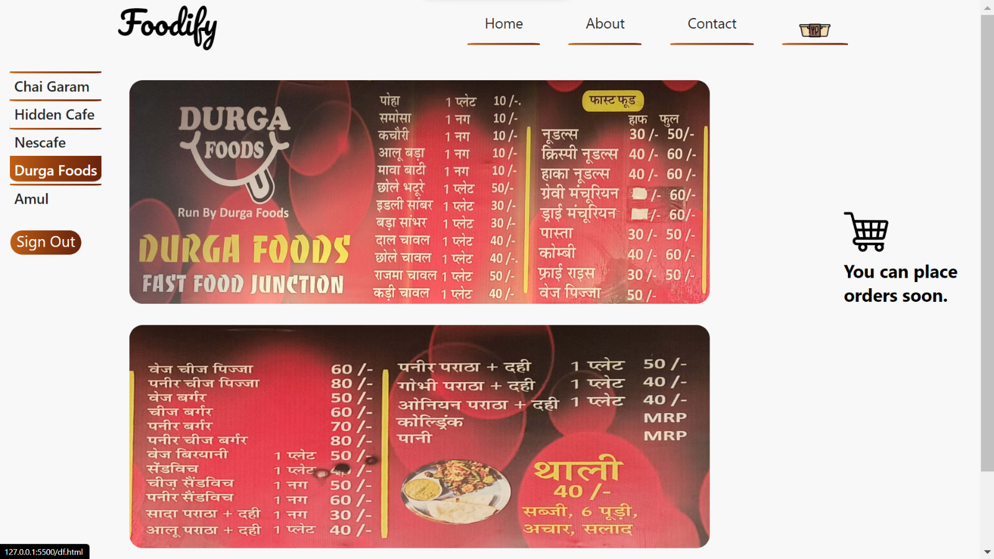

1. Amul: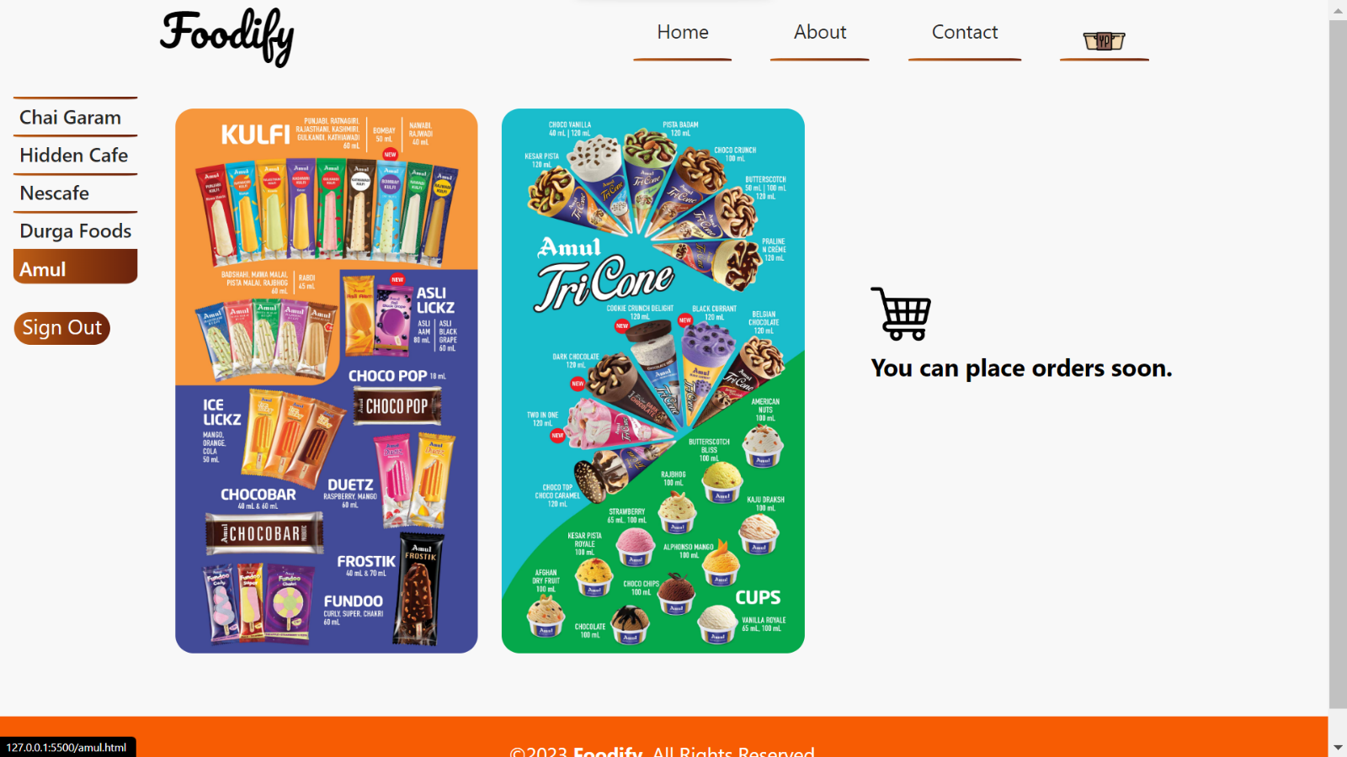

**5.Related Concepts and Principles**

## About HTML

The **HyperText Markup Language** or **HTML** is the standard markup language for documents de- signed to be displayed in a web browser. It can be assisted by technologies such as Cascading Style Sheets (CSS) and scripting languages such as JavaScript.

Web browsers receive HTML documents from a web server or from local storage and render the documents into multimedia web pages. HTML describes the structure of a webpage semantically and originally included cues for the appearance of the document.

HTML elements are the building blocks of HTML pages. With HTML constructs, images and other objects such as interactive forms may be embedded into the rendered page. HTML provides a means to create structured documents by denoting structural semantics for text such as headings, paragraphs, lists, links, quotes, and other items. HTML elements are delineated by *tags*, written us- ing angle brackets. Tags such as <**img** /> and <**input** /> directly introduce content into the page.

## 

## About CSS

**Cascading Style Sheets** (**CSS**) is a style sheet language used for describing the presentation of a document written in a markup language such as HTML or XML (including XML dialects such as SVG, MathML or XHTML). CSS is a cornerstone technology of the World Wide Web, alongside HTML and JavaScript.

CSS is designed to enable the separation of content and presentation, including layout, colors, and fonts. This separation can improve content accessibility; provide more flexibility and control in the specification of presentation characteristics; enable multiple web pages to share formatting by specifying the relevant CSS in a separate .css file, which reduces complexity and repetition in the structural content; and enable the .css file to be cached to improve the page load speed between the pages that share the file and its formatting.

**6.Hardware and Software Requirements**

## Recommended Operating Systems

* **Windows:**7 or newer
* **MAC:** OS X v10.7 or higher
* **Linux:** Ubuntu

## Hardware Requirements

We strongly recommend a computer fewer than 5 years old.

* Processor: Minimum 1 GHz; Recommended 2GHz or more
* Ethernet connection (LAN) OR a wireless adapter (Wi-Fi)
* Hard Drive: Minimum 32 GB; Recommended 64 GB or more
* Memory (RAM): Minimum 1 GB; Recommended 4 GB or above
* Sound card w/speakers
* Some classes require a camera and microphone

## Recommended Software

### Supported Browsers

Use whichever browser works best on your computer. However, we

recommend downloading Firefox and/or Chrome in addition to having

Internet Explorer or Safari.

* [Firefox](http://www.mozilla.com/)
* [Chrome](http://www.google.com/chrome/)

**7.Proposed Algorithm**

We have made this project using:

HTML

CSS

## HTML

**HTML** tutorial provides basic and advanced concepts of HTML. Our HTML tutorial is developed for on beginners level. In our tutorial, every topic is given step-by-step so that you can learn it in a very easy way. If you are new in learning HTML, then you can learn HTML from basic and after learning HTML with CSS and you will be able to create your own interactive and dynamic website.

## CSS

**CSS** provides basic and advanced concepts of CSS technology. Our CSS tutorial is developed for beginners and professionals. The major points of CSS are given below:

* + - CSS stands for Cascading Style Sheet.
    - CSS is used to design HTML tags.
    - CSS is a widely used language on the web.
    - HTML, CSS and JavaScript are used for web designing. It helps the web designers to apply style on HTML tags.

**8.References**

1. **W3Schools:** [**https://www.w3schools.com/html/**](https://www.w3schools.com/html/)
2. **GitHub:** [**https://www.github.com**](https://www.github.com)
3. **Google Fonts:** [**https://fonts.google.com/**](https://fonts.google.com/)
4. **Flaticon:** [**https://www.flaticon.com/**](https://www.flaticon.com/)
5. **Unsplash:** [**https://unsplash.com/**](https://unsplash.com/)